**TO GET INPUT FROM CONSOLE**

**EXERCISE 141:**

**AIM:**

**import** java.util.Scanner;

**public** **class** ex141 {

**public** **static** **void** main(String[] args) {

// **TODO** Auto-generated method stub

Scanner sc=**new** Scanner(System.*in*);

System.*out*.println("Enter your rollno");

**int** rollno=sc.nextInt();

System.*out*.println("Enter your name");

String name=sc.next();

System.*out*.println("Enter your fee");

**double** fee=sc.nextDouble();

System.*out*.println("Rollno:"+rollno+" name:"+name+" fee:"+fee);

sc.close();

}

}

**OUTPUT:**

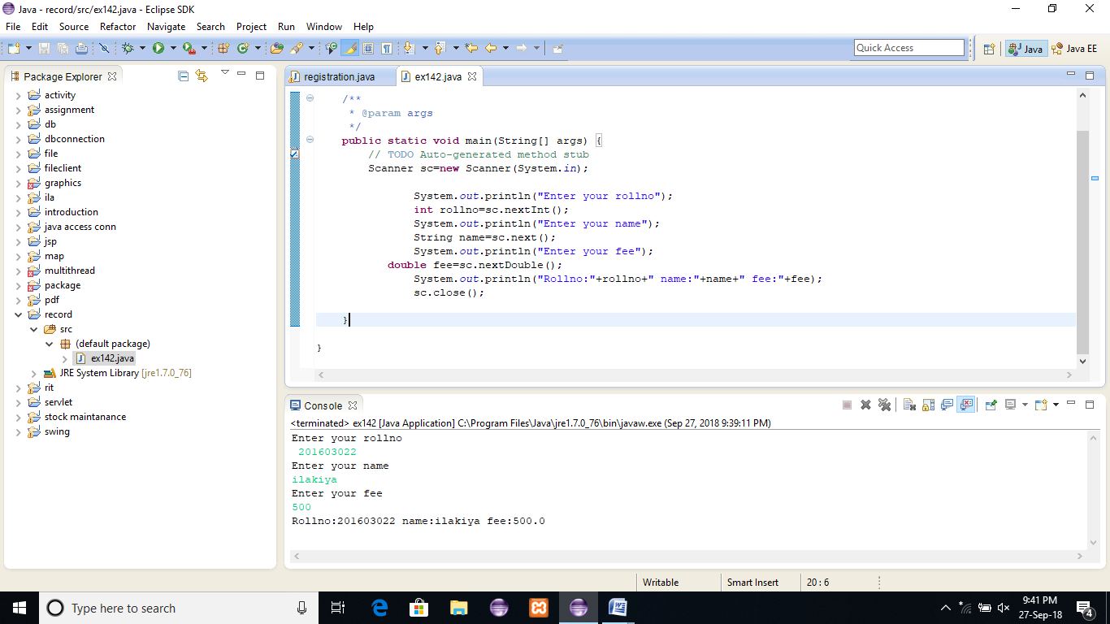

**RESULT:**

### PRINTSTREAM CLASS:

**EXERCISE 142:**

**AIM:**

**import** java.io.*;

**public** **class** ex142 {

/**

* **@param** args

*/

**public** **static** **void** main(String[] args) **throws** Exception{

// **TODO** Auto-generated method stub

FileOutputStream fout=**new** FileOutputStream("mfile.txt");

PrintStream pout=**new** PrintStream(fout);

pout.println(1900);

pout.println("Hello Java");

pout.println("Welcome to Java");

pout.close();

fout.close();

}

**OUTPUT:**

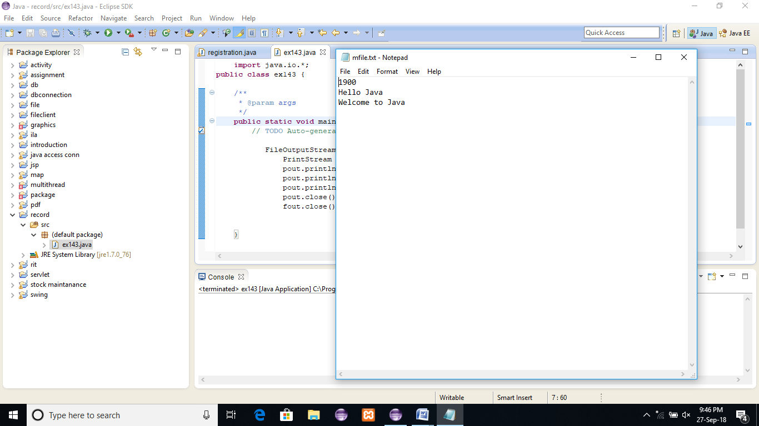

**RESULT:**

### PRINTF() METHOD OF JAVA.IO.PRINTSTREAM CLASS:

**EXERCISE 143:**

**AIM:**

**public** **class** ex143 {

**public** **static** **void** main(String[] args) {

**int** a=10;

System.*out*.printf("%d",a);//Note, out is the object of PrintStream class

}

}

**OUTPUT:**

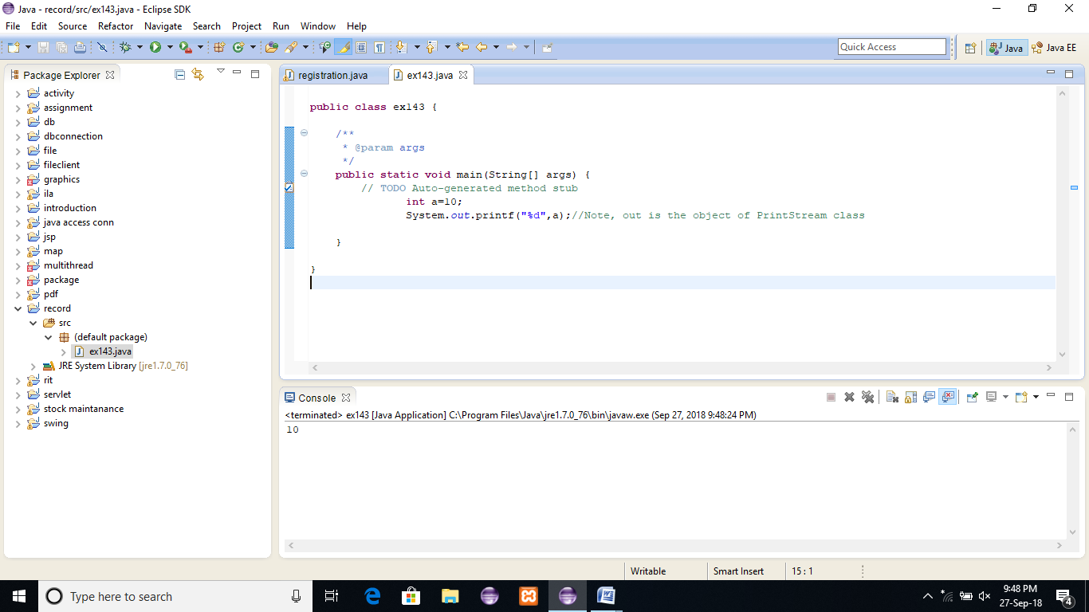

**RESULT:**

### COMPRESSING FILE USING DEFLATEROUTPUTSTREAM CLASS

**EXERCISE 144:**

**AIM:**

**import** java.io.*;

**import** java.util.zip.*;

**public** **class** ex144 {

/**

* **@param** args

*/

**public** **static** **void** main(String[] args) {

// **TODO** Auto-generated method stub

**try**{

FileInputStream fin=**new** FileInputStream("Deflater.java");

FileOutputStream fout=**new** FileOutputStream("def.txt");

DeflaterOutputStream out=**new** DeflaterOutputStream(fout);

**int** i;

**while**((i=fin.read())!=-1){

out.write((**byte**)i);

out.flush();

}

fin.close();

out.close();

}**catch**(Exception e){System.*out*.println(e);}

System.*out*.println("rest of the code");

}

}

**OUTPUT:**

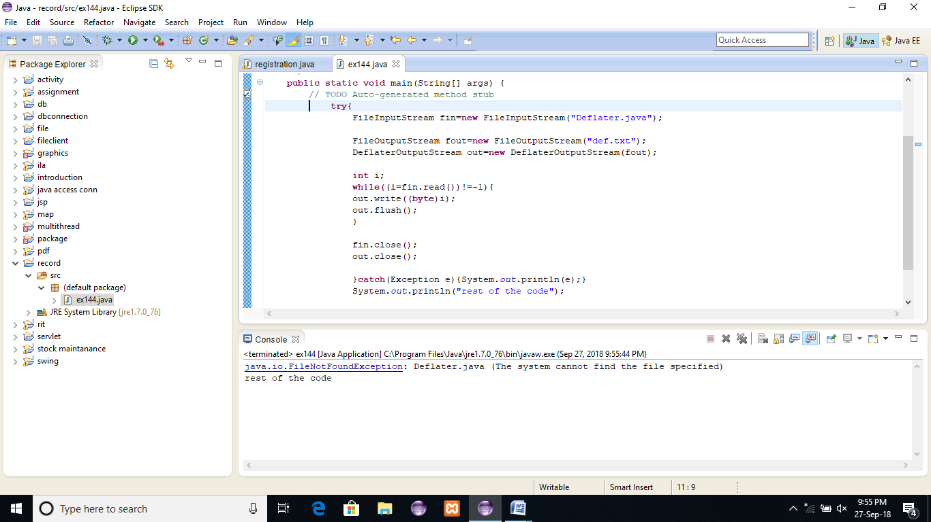

**RESULT:**

### PIPEDINPUTSTREAM AND PIPEDOUTPUTSTREAM

**EXERCISE 145:**

**AIM:**

**import** java.io.*;

**public** **class** ex145 {

/**

* **@param** args

*/

**public** **static** **void** main(String[] args)**throws** Exception{

**final** PipedOutputStream pout=**new** PipedOutputStream();

**final** PipedInputStream pin=**new** PipedInputStream();

pout.connect(pin);//connecting the streams

//creating one thread t1 which writes the data

Thread t1=**new** Thread(){

**public** **void** run(){

**for**(**int** i=65;i<=90;i++){

**try**{

pout.write(i);

Thread.*sleep*(1000);

}**catch**(Exception e){}

}

}

};

//creating another thread t2 which reads the data

Thread t2=**new** Thread(){

**public** **void** run(){

**try**{

**for**(**int** i=65;i<=90;i++)

System.*out*.println(pin.read());

}**catch**(Exception e){}

}

};

//starting both threads

t1.start();

t2.start();

}

}

**OUTPUT:**

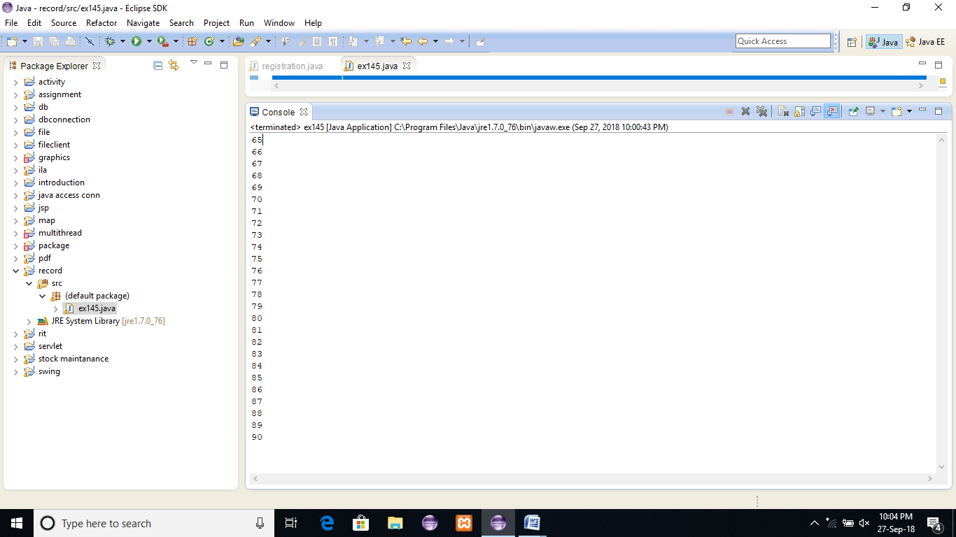

**RESULT:**

## JAVA URL CLASS

**EXERCISE 146:**

**AIM:**

**import** java.io.*;

**import** java.net.*;

**public** **class** ex146 {

/**

* **@param** args

*/

**public** **static** **void** main(String[] args){

**try**{

URL url=**new** URL("http://www.google.com");

System.*out*.println("Protocol: "+url.getProtocol());

System.*out*.println("Host Name: "+url.getHost());

System.*out*.println("Port Number: "+url.getPort());

System.*out*.println("File Name: "+url.getFile());

}**catch**(Exception e){System.*out*.println(e);}

}

}

**OUTPUT:**

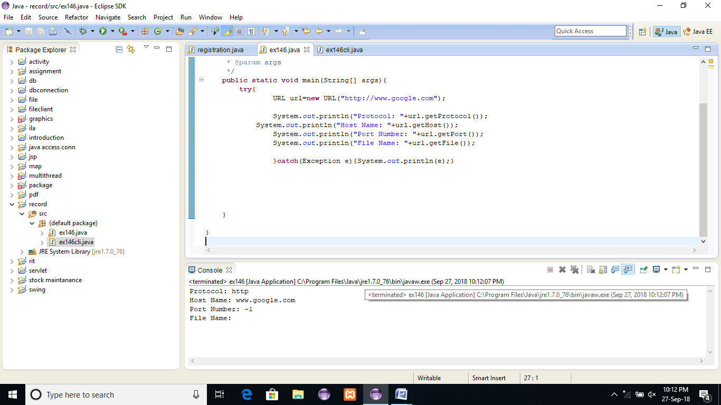

**RESULT:**

### JAVA URLCONNECTON CLASS

**EXERCISE 147:**

**AIM:**

**import** java.io.*;

**import** java.net.*;

**public** **class** ex147 {

/**

* **@param** args

*/

**public** **static** **void** main(String[] args) {

// **TODO** Auto-generated method stub

**try**{

URL url=**new** URL("http://www.google.com");

URLConnection urlcon=url.openConnection();

InputStream stream=urlcon.getInputStream();

**int** i;

**while**((i=stream.read())!=-1){

System.*out*.print((**char**)i);

}

}**catch**(Exception e){System.*out*.println(e);}

}

}

**OUTPUT:**

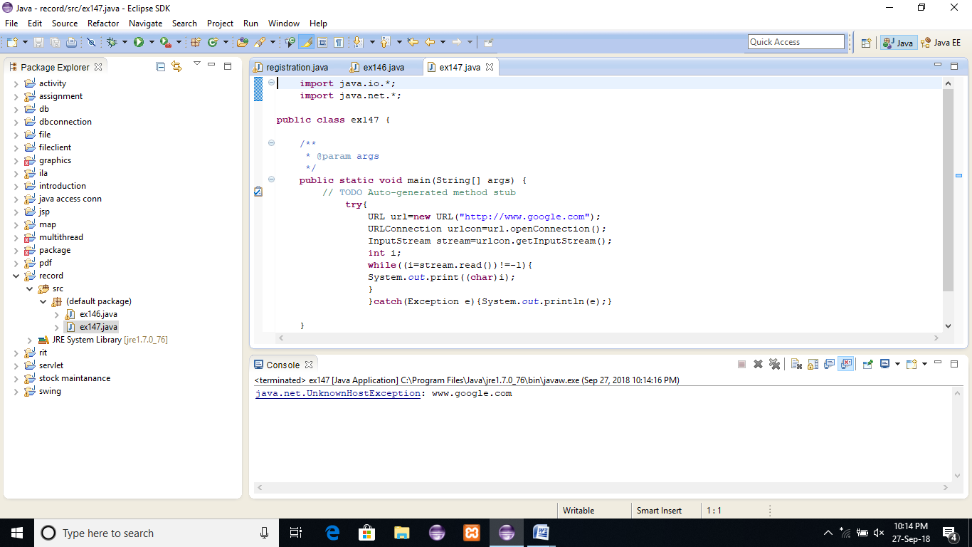

**RESULT:**

## JAVA HTTPURLCONNECTON EXAMPLE

**EXERCISE 148:**

**AIM:**

**import** java.io.*;

**import** java.net.*;

**public** **class** ex148 {

/**

* **@param** args

*/

**public** **static** **void** main(String[] args) {

// **TODO** Auto-generated method stub

**try**{

URL url=**new** URL("http://www.google.com");

HttpURLConnection huc=(HttpURLConnection)url.openConnection();

**for**(**int** i=1;i<=8;i++){

System.*out*.println(huc.getHeaderFieldKey(i)+" = "+huc.getHeaderField(i));

}

huc.disconnect();

}**catch**(Exception e){System.*out*.println(e);}

}

}

**OUTPUT:**

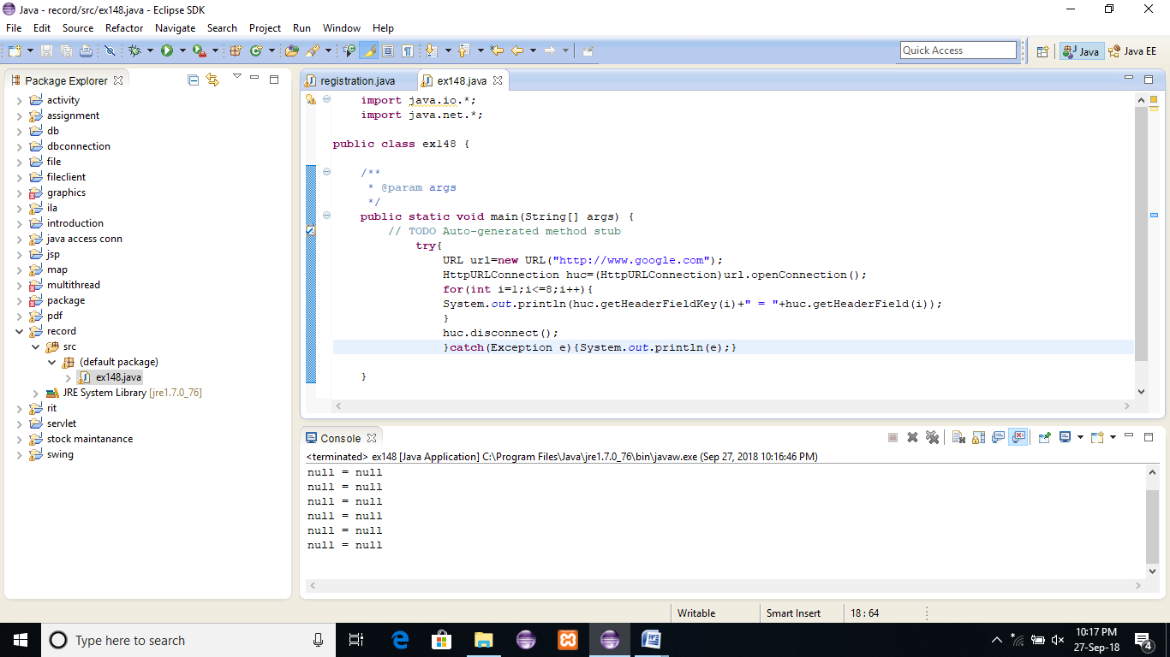

**RESULT:**

## JAVA INETADDRESS CLASS

**EXERCISE 149:**

**AIM:**

**import** java.io.*;

**import** java.net.*;

**public** **class** ex149 {

/**

* **@param** args

*/

**public** **static** **void** main(String[] args) {

// **TODO** Auto-generated method stub

**try**{

InetAddress ip=InetAddress.*getByName*("www.google.com");

System.*out*.println("Host Name: "+ip.getHostName());

System.*out*.println("IP Address: "+ip.getHostAddress());

}**catch**(Exception e){System.*out*.println(e);}

}

}

**OUTPUT:**

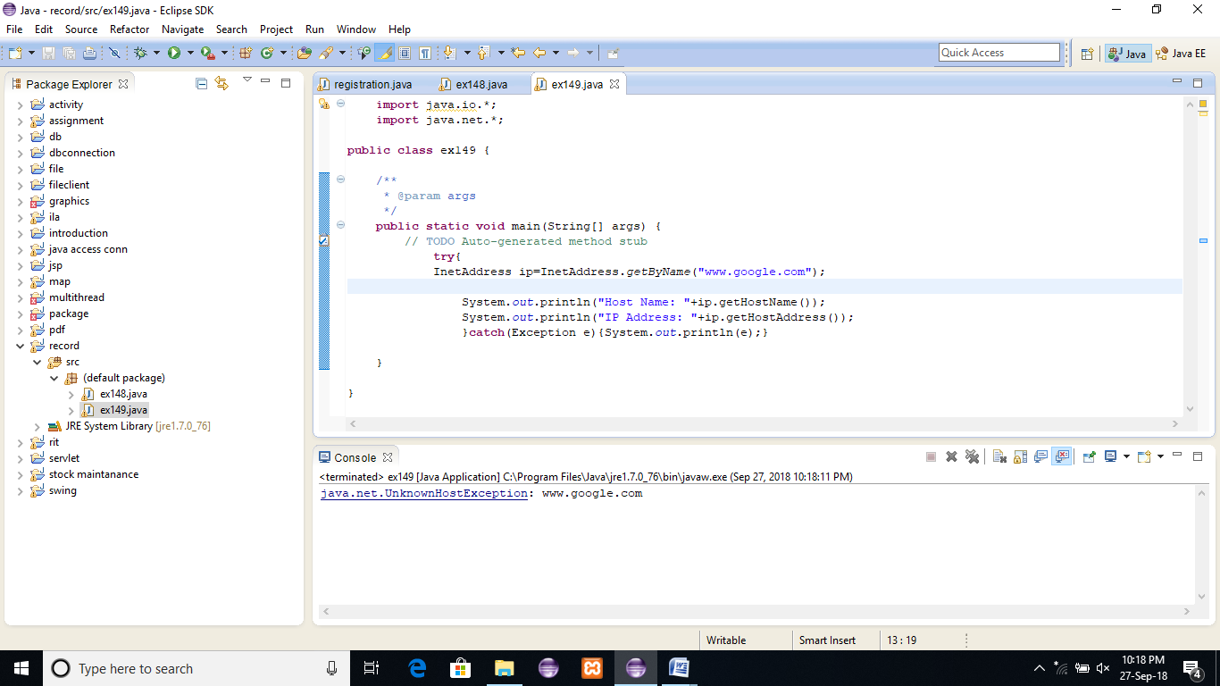

**RESULT:**

### SIMPLE EXAMPLE OF AWT BY INHERITANCE

**EXERCISE 150:**

**AIM:**

**import** java.awt.*;

**public** **class** ex150 **extends** Frame {

ex150(){

Button b=**new** Button("click me");

b.setBounds(30,100,80,30);// setting button position

add(b);//adding button into frame

setSize(300,300);//frame size 300 width and 300 height

setLayout(**null**);//no layout manager

setVisible(**true**);//now frame will be visible, by default not visible

}

**public** **static** **void** main(String args[]){

ex150 f=**new** ex150();

}

}

**OUTPUT:**

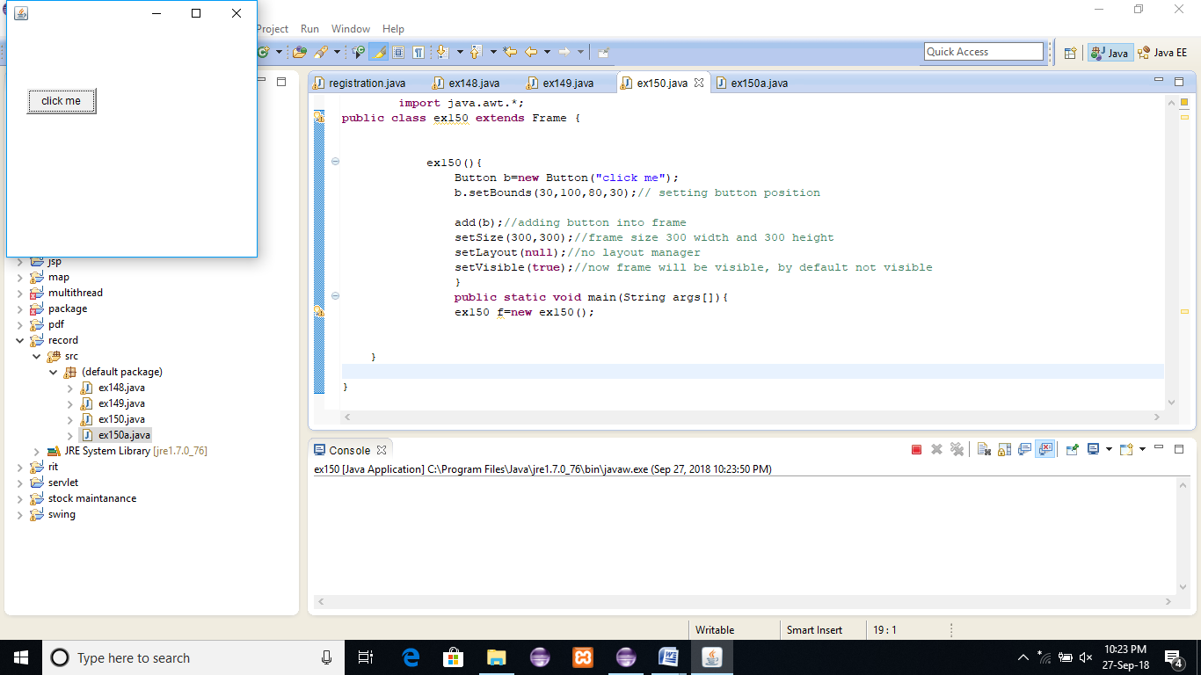

**RESULT:**